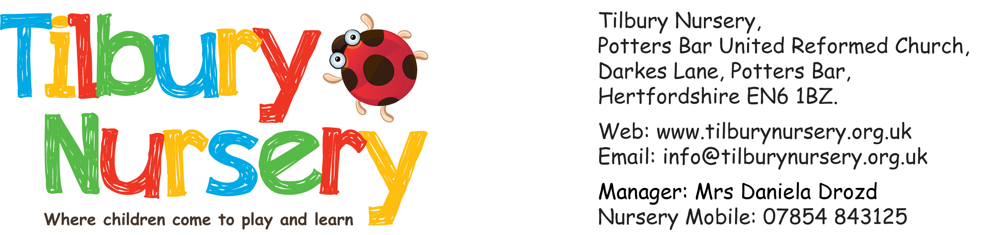

APPLICATION FORM

Full name of child: __________________________________________ Boy or girl? ___________

Date of birth: _______________ NHS no: _________________Ethnicity code (see over): _______

2 Year old funding No. (if applicable): __________ 30 hour funding No. (if applicable): ___________

When would you like your child to start Nursery? ______________________________________

What are the preferred days? _______________________ Any days unavailable? _____________

To which school are you hoping to send your child and when?________________________________

Names of parents: ______________________________________________________________

Full home address: ______________________________________________________________

___________________________________________________ Post Code: ________________

Email address: _________________________________________________________________

Telephone numbers: _____________________________________________________________
A non-refundable registration fee of £10.00 is payable with this application. (If you are not in receipt of HCC funding).
Cheques should be made payable to Tilbury Nursery.
Signature of parent: ________________________________________ Date: _______________
How did you hear about Tilbury Nursery: _____________________________________________
For office use only: £10.00 fee received cash / cheque __________________ Date: ____________

DEPARTMENT FOR EDUCATION ETHNIC ORIGIN CODES

DfE APPROVED CATEGORIES | CODE | DfE APPROVED CATEGORIES | CODE
WHITE |  | CHINESE
White - British | WBRI | Chinese | CHNE
White - Cornish |  | Hong Kong Chinese
White - English |  | Malaysian Chinese
White - Scottish |  | Singaporean Chinese
White - Welsh |  | Taiwanese
Other White British |  | Other Chinese
White - Irish | WIRI | ASIAN OR ASIAN BRITISH
Traveller of Irish Heritage | WIRT | Indian | AIND
Italian | WITA | Pakistani | APKN
Turkish/ Turkish Cypriot | WTUR | Mirpuri Pakistani
Any Other White Background | WOTW | Kashmiri Pakistani
Albanian |  | Other Pakistani
Bosnian- Herzegovinian |  | Bangladeshi | ABAN
Croatian |  | Any Other Asian Background | AOTH
Greek/ Greek Cypriot |  | African Asian
Greek |  | Kashmiri Other
Greek Cypriot |  | Nepali
Kosovan |  | Sri Lankan Sinhalese
Portuguese |  | Sri Lankan Tamil
Serbian |  | Sri Lankan Other
White European |  | Other Asian
White Other |  | ANY OTHER ETHNIC GROUP | OOTH
Gypsy / Roma | WROM | Afghan
MIXED / DUAL BACKGROUND |  | Arab Other
White and Black Caribbean | MWBC | Egyptian
White and Black African | MWBA | Filipino
White and Asian | MWAS | Iranian
White and Pakistani |  | Iraqi
White and Indian |  | Japanese
White and Any Other Asian Background |  | Korean
Any Other Mixed Background | MOTH | Kurdish
Asian and Any Other Ethnic Group |  | Latin/ South/ Central American
Asian and Black |  | Lebanese
Asian and Chinese |  | Libyan
Black and Any Other Ethnic Group |  | Malay
Black and Chinese |  | Moroccan
Chinese and Any Other Ethnic Group |  | Polynesian
White and Any Other Ethnic Group |  | Thai
White and Chinese |  | Vietnamese
Other Mixed Background |  | Yemeni
BLACK OR BLACK BRITISH |  | Other Ethnic Group
Black Caribbean | BCRB | Please circle the category  which best describes your child.  Thank you!
Black African | BAFR
Black - Angolan
Black - Congolese
Black - Ghanaian
Black - Nigerian
Black - Sierra Leonean
Black - Somali
Black - Sudanese
Other Black African
Any Other Black Background | BOTH
Black European
Black North American
Other Black

